Note: these answers for lec 2,4,5 & My attempts to improve the solution.

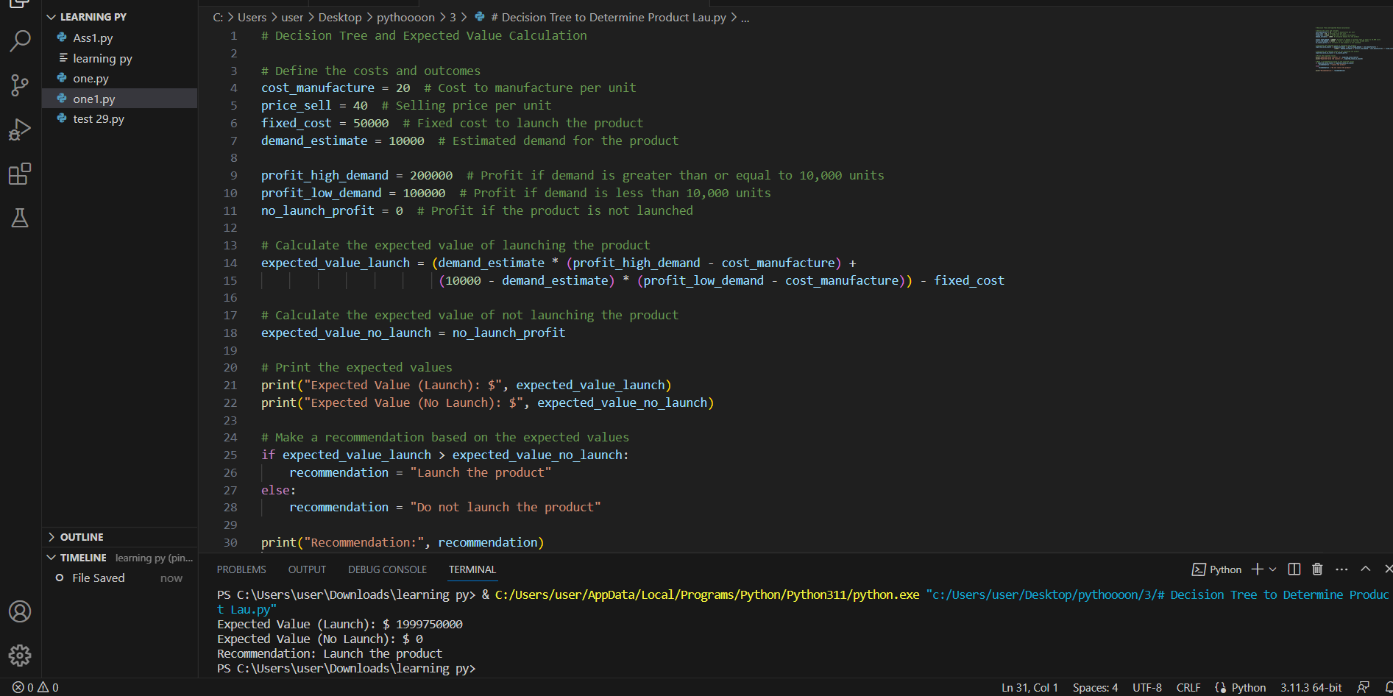

Based on the analysis, the expected value of launching the product is the expected profit from selling the units minus the cost of manufacturing and the fixed launch cost. The expected value of not launching the product is zero, as there is no profit or loss.

The calculated expected value can be used to make a recommendation. If the expected value of launching the product is higher than the expected value of not launching it, the recommendation would be to launch the product. Otherwise, the recommendation would be not to launch the product.

Additional factors before start new product:

1. Market Competition
2. Consumer Demand and Trends
3. Marketing and Advertising Costs

Model evaluation A :

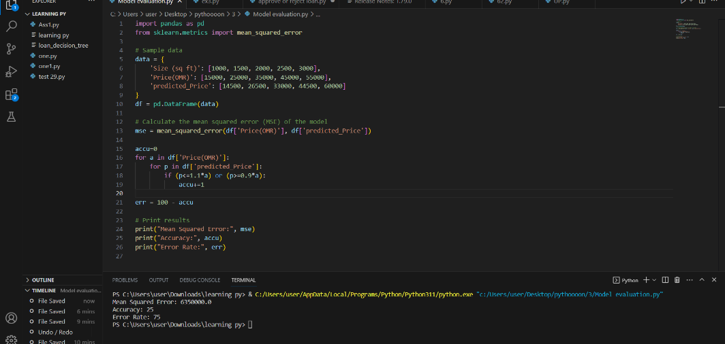

Comment on the accuracy of this model:

The accuracy of the model, as can be seen from the presented results, is relatively low.

A mean squared error (MSE) of 63,500,000.0 indicates that the model's predictions have a significant amount of error or variance when compared to actual prices. A higher MSE value indicates a greater discrepancy between predicted and actual values.

An accuracy of 25% indicates that only a quarter of expected prices are within 0.9 times the actual price and 1.1 times the actual price. This indicates that the majority of forecasts deviate significantly from actual prices, which results in a lower accuracy rate.

With an error rate of 75%, it indicates that 75% of the projected prices do not meet the criteria of being within the specified range of 0.9 to 1.1 times the actual price. This highlights a high level of imprecision in the model's predictions.

.



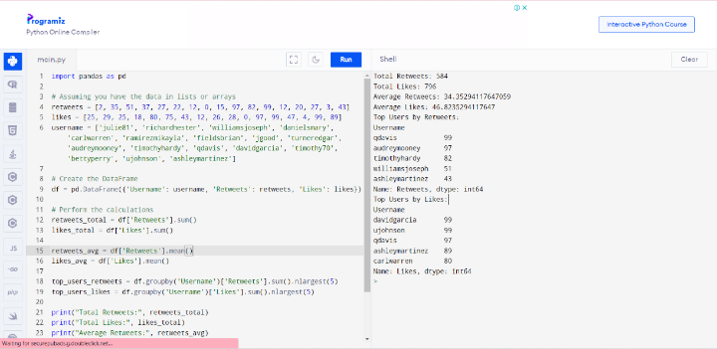

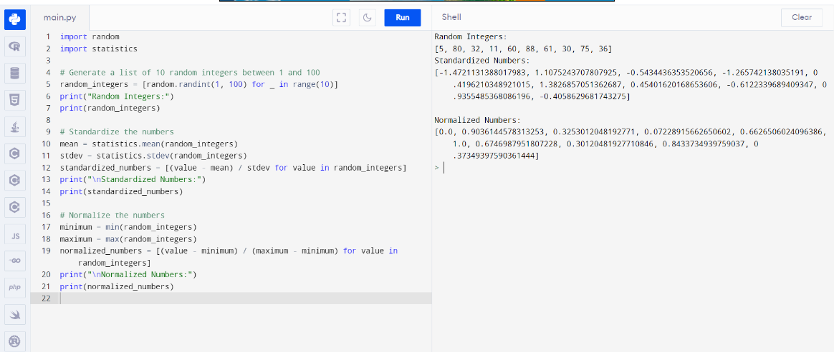Q2

Q3:

